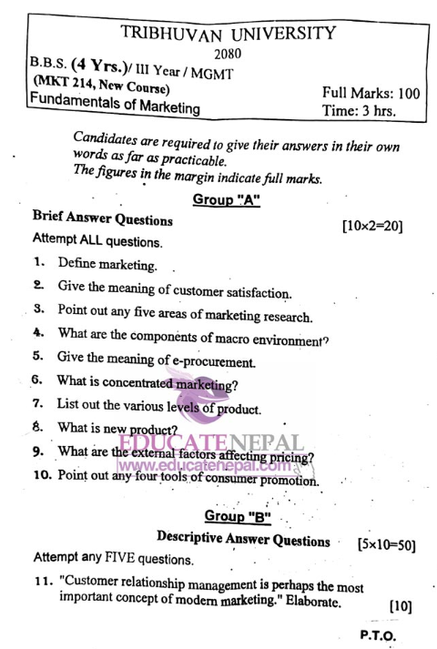
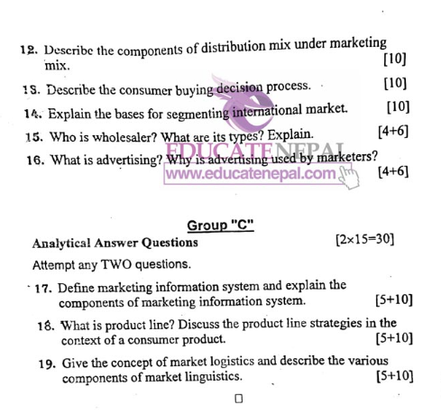

1. Define marketing.
Marketing is the process of identifying customer needs and providing products or services to satisfy them.
मार्केटिङ भन्नाले ग्राहकको आवश्यकता पहिचान गरी तिनीहरूलाई सन्तुष्ट पार्न वस्तु वा सेवा उपलब्ध गराउने प्रक्रिया हो।

2. Give the meaning of customer satisfaction.
Customer satisfaction refers to the level of happiness or contentment a customer feels after purchasing and using a product or service.
ग्राहक सन्तुष्टि भन्नाले ग्राहकले कुनै वस्तु वा सेवा खरिद गरी प्रयोग गरेपछि महसुस गर्ने सन्तोषजनक अवस्थालाई जनाउँछ।

3. Point out any five areas of marketing research.
- Product research
- Price research
- Promotion research
- Distribution research
- Consumer behavior research
१. उत्पादन अनुसन्धान
२. मूल्य अनुसन्धान
३. प्रचार अनुसन्धान
४. वितरण अनुसन्धान
५. उपभोक्ता व्यवहार अनुसन्धान

4. What are the components of macro environment?
- Demographic environment
- Economic environment
- Political environment
- Technological environment
- Socio-cultural environment
१. जनसांख्यिक वातावरण
२. आर्थिक वातावरण
३. राजनीतिक वातावरण
४. प्रविधि वातावरण
५. सामाजिक-सांस्कृतिक वातावरण

5. Give the meaning of e-procurement.
E-procurement is the process of purchasing goods and services using the internet or electronic systems.
ई-प्रोक्योरमेन्ट भन्नाले इन्टरनेट वा विद्युतीय प्रणालीको माध्यमबाट सामान वा सेवाहरू खरिद गर्ने प्रक्रिया हो।

6. What is concentrated marketing?
Concentrated marketing is a strategy where a company focuses its marketing efforts on a single market segment.
केन्द्रित बजारिकरण भन्नाले कुनै व्यवसायले एउटा विशेष बजार समूहलाई लक्षित गरेर गर्ने बजारिकरण रणनीति हो।

7. List out the various levels of the product.
- Core product
- Actual product
- Augmented product
१. मुख्य उत्पादन
२. वास्तविक उत्पादन
३. बृद्धि गरिएको उत्पादन

8. What is new product?
A new product is a product that is newly developed or significantly improved and introduced to the market.
नयाँ उत्पादन भन्नाले नयाँ बनाईएको वा धेरै सुधार गरिएको र बजारमा ल्याइएको वस्तु वा सेवालाई जनाउँछ।

9. What are the external factors affecting pricing?
- Market demand
- Competitor’s price
- Government policies
- Economic conditions
१. बजार माग
२. प्रतिस्पर्धीको मूल्य
३. सरकारी नीतिहरू
४. आर्थिक अवस्था

10. Point out any four tools of consumer promotion.
- Discount
- Coupons
- Free samples
- Contests
१. छुट
२. कुपन
३. निःशुल्क नमुना
४. प्रतियोगिता
12. Describe the components of distribution mix under marketing mix. [10 Marks]
Definition:
Distribution mix refers to the combination of various elements used by a company to make its products available to consumers.
Components of Distribution Mix:
- Channel of Distribution – Pathways through which goods move from producer to consumer (e.g., wholesalers, retailers).
- Transportation – Physical movement of goods using different modes like road, rail, air, etc.
- Warehousing – Storage of goods before delivery to maintain a steady supply.
- Inventory Control – Managing stock levels to avoid overstocking or understocking.
- Order Processing – Activities related to receiving, handling, and fulfilling customer orders.
- Logistics – Coordinating transportation, warehousing, and delivery to ensure smooth product flow.

13. Describe the consumer buying decision process. [10 Marks]
Definition:
The consumer buying decision process is the series of steps a customer goes through before purchasing a product.
Steps of Consumer Buying Decision Process:
- Problem Recognition – Realizing a need or problem.
- Information Search – Gathering information about possible solutions.
- Evaluation of Alternatives – Comparing available options.
- Purchase Decision – Choosing and buying a product.
- Post-Purchase Behavior – Consumer’s experience after the purchase, leading to satisfaction or dissatisfaction.

14. Explain the bases for segmenting international market. [10 Marks]
Definition:
Market segmentation is dividing a large market into smaller groups based on certain characteristics for effective marketing.
Bases of Segmenting International Market:
- Geographic Segmentation – Based on countries, regions, climate, etc.
- Demographic Segmentation – Based on population, income, age, education, gender, etc.
- Psychographic Segmentation – Based on lifestyle, personality, values.
- Behavioral Segmentation – Based on usage rate, brand loyalty, benefits sought.
- Cultural Segmentation – Based on language, religion, traditions.

15. Who is wholesaler? What are its types? Explain. [4+6 Marks]
Definition of Wholesaler:
A wholesaler is a person or firm that buys goods in bulk from producers and sells them to retailers or other businesses.
Types of Wholesalers:
- Merchant Wholesalers – Own and resell the products.
- Agents and Brokers – Help in selling without taking ownership.
- Manufacturers’ Sales Branches – Owned by manufacturers to distribute their products.
- Specialty Wholesalers – Deal in specific products or industries.
- Cash-and-Carry Wholesalers – Sell to small retailers who pay in cash and arrange their own transport.

16. What is advertising? Why is advertising used by marketers? [4+6 Marks]
Definition of Advertising:
Advertising is a paid form of non-personal communication used to promote products, services, or ideas to a target audience.
Why Advertising is Used by Marketers:
- To Create Awareness – Inform people about the product.
- To Persuade Customers – Convince customers to buy.
- To Build Brand Image – Create a positive perception of the brand.
- To Increase Sales – Ultimately boost the company’s revenue.
- To Face Competition – Differentiate products from competitors.
- To Introduce New Products – Launching new products in the market.

17. Define marketing information system and explain the components of marketing information system. [5+10]
English Answer:
Definition:
A Marketing Information System (MIS) is a structured arrangement of people, equipment, and procedures to collect, sort, analyze, evaluate, and distribute necessary marketing information to managers for decision-making.
Components of Marketing Information System:
- Internal Records:
- Sales records, customer databases, inventory, financial data.
- Marketing Intelligence:
- Collection of everyday market data (competitors’ activities, market trends).
- Marketing Research:
- Systematic research and analysis for solving specific marketing problems.
- Analytical Marketing System:
- Tools and models to process information for better decision-making.
- Information Storage and Retrieval System:
- Databases for storing marketing information.

नेपाली उत्तर:
परिभाषा:
मार्केटिङ सूचना प्रणाली (MIS) भन्नाले व्यवसायमा आवश्यक पर्ने सूचना संकलन, विश्लेषण, व्यवस्थापन र वितरण गर्न प्रयोग हुने संरचित प्रणाली हो।
मार्केटिङ सूचना प्रणालीका तत्वहरू:
१. आन्तरिक अभिलेखहरू:
- बिक्री अभिलेख, ग्राहक विवरण, भण्डारण डेटा।
२. बजार खुफिया:
- बजारमा दैनिक रूपमा भइरहने सूचना (प्रतिस्पर्धीको गतिविधि, बजार प्रवृत्ति)।
३. बजार अनुसन्धान:
- विशेष समस्याको समाधान गर्न प्रणालीगत अनुसन्धान।
४. विश्लेषणात्मक प्रणाली:
- निर्णय प्रक्रियामा सहयोग पुर्‍याउने उपकरणहरू र मोडेलहरू।
५. सूचना भण्डारण प्रणाली:
- सूचना भण्डारण र खोजी गर्न प्रयोग हुने डाटाबेसहरू।

18. What is product line? Discuss the product line strategies in the context of a consumer product. [5+10]
English Answer:
Definition:
A product line is a group of related products produced by a company and marketed under a single brand.
Product Line Strategies:
- Product Line Stretching:
- Upward Stretching: Introducing higher-end products.
- Downward Stretching: Introducing cheaper products.
- Two-Way Stretching: Both high-end and low-end products.
- Product Line Filling:
- Adding new products in the existing range to fill market gaps.
- Product Line Pruning:
- Removing less profitable or outdated products.
Example (Consumer Product):
A toothpaste company may offer herbal, whitening, kids’ toothpaste (product line filling), premium toothpaste (upward stretching), and economy toothpaste (downward stretching).

नेपाली उत्तर:
परिभाषा:
उत्पादन लाइन भन्नाले एउटै ब्रान्ड अन्तर्गत कम्पनीले उत्पादन गर्ने समान प्रकृतिका वस्तुहरूको समूहलाई जनाउँछ।
उत्पादन लाइन रणनीतिहरू:
१. उत्पादन लाइन स्ट्रेचिङ:
- माथिल्लो स्ट्रेचिङ: महँगो र प्रिमियम वस्तुहरू ल्याउने।
- तल्लो स्ट्रेचिङ: सस्तो उत्पादन ल्याउने।
- द्वैतरूप स्ट्रेचिङ: महँगो र सस्तो दुबै ल्याउने।
२. उत्पादन लाइन फिलिङ:
- बजारको खाली स्थान भर्न नयाँ उत्पादन ल्याउने।
३. उत्पादन लाइन कटौती:
- अलपत्र र घाटामा जान लागेका वस्तु हटाउने।
उदाहरण (उपभोक्ता उत्पादन):
टुथपेस्ट कम्पनीले हर्बल, व्हाइटनिङ, बालबालिकाको लागि टुथपेस्ट ल्याउने (फिलिङ), प्रिमियम टुथपेस्ट ल्याउने (अपवर्ड स्ट्रेचिङ), सस्तो टुथपेस्ट ल्याउने (डाउनवर्ड स्ट्रेचिङ)।

19. Give the concept of market logistics and describe the various components of market logistics. [5+10]
English Answer:
Definition:
Market logistics refers to the planning, implementing, and controlling of the efficient flow of goods, services, and information from point of origin to point of consumption.
Components of Market Logistics:
- Order Processing:
- Receiving, checking, and fulfilling customer orders.
- Warehousing:
- Safe storage of goods until needed.
- Inventory Management:
- Controlling the stock levels to meet demand efficiently.
- Transportation:
- Moving goods to customers using road, rail, air, or water.
- Logistics Information System:
- Using computerized systems to track, record, and analyze logistics data.

नेपाली उत्तर:
परिभाषा:
बजार लजिस्टिक्स भन्नाले उत्पादन स्थलबाट उपभोक्तासम्म सामान, सेवा र सूचनाको प्रभावकारी प्रवाह योजना बनाउने, कार्यान्वयन गर्ने र नियन्त्रण गर्ने प्रक्रिया हो।
बजार लजिस्टिक्सका तत्वहरू:
१. अर्डर प्रोसेसिङ:
- ग्राहकको अर्डर प्राप्त गर्ने, जाँच गर्ने र पुरा गर्ने।
२. वेयरहाउसिङ (भण्डारण):
- आवश्यक पर्दासम्म सामानहरू सुरक्षित राख्ने।
३. इन्भेन्टोरी व्यवस्थापन:
- माग र आपूर्तिको सन्तुलन मिलाउन स्टक नियन्त्रण गर्ने।
४. ढुवानी:
- सडक, रेल, हवाई वा जलमार्गबाट सामान पठाउने।
५. लजिस्टिक्स सूचना प्रणाली:
- कम्प्युटर प्रणाली प्रयोग गरी सम्पूर्ण लजिस्टिक्स प्रक्रिया निगरानी गर्ने।

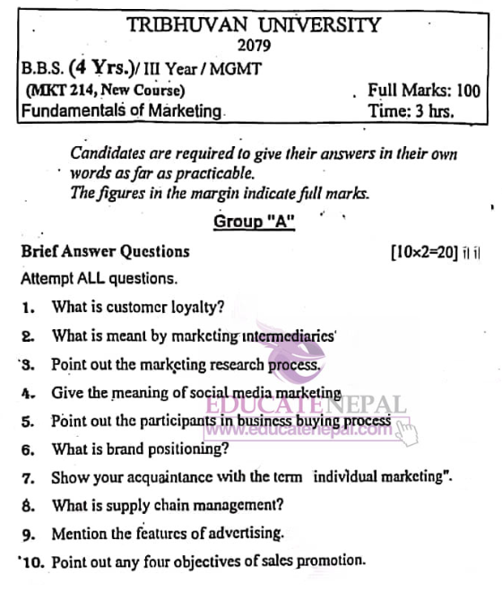
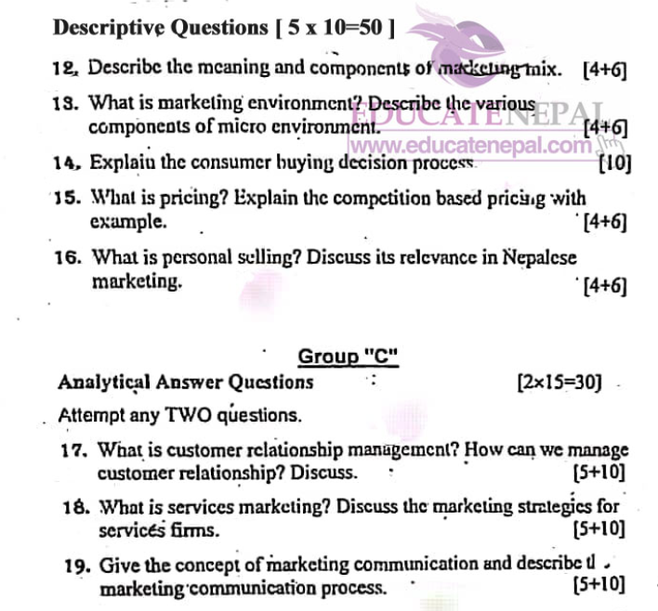

1. define customer loyalty
Customer loyalty refers to the strong and consistent preference of customers towards a particular brand, product, or service over its competitors. Loyal customers repeatedly purchase from the same business due to satisfaction, trust, and emotional connection.
Example:
If a customer always buys Samsung phones because they trust the brand, that is customer loyalty.
ग्राहक निष्ठा भन्नाले कुनै विशेष ब्रान्ड, उत्पादन वा सेवाप्रति ग्राहकको दीर्घकालीन र निरन्तर झुकाव जनाउने भावना हो। ग्राहकहरूले सन्तुष्टि, विश्वास र भावनात्मक सम्बन्धका कारण बारम्बार एउटै ब्रान्ड वा सेवाको प्रयोग गर्छन्।
उदाहरण:
यदि ग्राहकले सधैं Samsung मोबाइल किन्छ भने, त्यो ग्राहक निष्ठा हो।

12. Describe the meaning and components of the marketing mix.
🇬🇧 English Answer:
Meaning of Marketing Mix:
The marketing mix is a set of tools and tactics used by businesses to promote and sell their products and services effectively. It is comprised of four main elements, often called the 4Ps:
- Product: The goods or services offered by a company.
- Price: The cost customers pay for the product.
- Place: The distribution channels used to deliver the product.
- Promotion: The methods used to communicate with the target market.
Components of the Marketing Mix:
- Product: Quality, design, branding, packaging.
- Price: Pricing strategies, discounts, terms of sale.
- Place: Location, distribution channels, logistics.
- Promotion: Advertising, sales promotion, public relations.
🇳🇵 Nepali Answer:
मार्केटिङ मिक्सको अर्थ:
मार्केटिङ मिक्स भन्नाले कम्पनीले आफ्नो उत्पादन वा सेवाहरूलाई बजारमा पुर्‍याउन र बेच्न प्रयोग गर्ने उपकरण र नीति समुहलाई बुझाउँछ । यसलाई सामान्यतया “४ पी” भनिन्छ:
- उत्पादन: कम्पनीद्वारा उपलब्ध गराइने वस्तु वा सेवा।
- मूल्य: ग्राहकबाट लिइने रकम।
- स्थान: वितरणका माध्यमहरू र स्थानहरू।
- प्रवर्द्धन: प्रचार-प्रसार र संवादका विधिहरू।
घटकहरू:
- उत्पादन: गुणस्तर, डिज़ाइन, ब्रान्डिङ, प्याकेजिङ्ग
- मूल्य: मूल्य निर्धारण नीति, छुट र सर्तहरू
- स्थान: स्थान, वितरण च्यानलहरू, लजिस्टिक्स
- प्रवर्द्धन: विज्ञापन, बिक्री प्रवर्द्धन, जनसम्पर्क

13. What is marketing environment? Describe the various components of micro environment.
🇬🇧 English Answer:
Marketing Environment: The marketing environment is comprised of internal and external forces that affect an organization's ability to build successful relationships with customers.
Micro Environment:
- Customers: The target audience for products/services.
- Suppliers: Provide resources for the business.
- Intermediaries: Agents, wholesalers, retailers.
- Competitors: Other businesses offering similar products.
- Public: Media, pressure groups, and the general public.
🇳🇵 Nepali Answer:
मार्केटिङ वातावरण: कम्पनीलाई ग्राहकहरूसँग सफल सम्बन्ध स्थापित गर्न असर गर्ने आन्तरिक र बाह्य तत्वहरूलाई मार्केटिङ वातावरण भनिन्छ।
माइक्रो वातावरणका घटकहरू:
- ग्राहकहरू: उत्पादन/सेवाका लक्षित उपभोक्ताहरू
- आपूर्तिकर्ताहरू: कम्पनीलाई कच्चा पदार्थ आपूर्ति गर्नेहरू
- मध्यस्थहरू: एजेन्टहरू, थोक र खुद्रा व्यापारीहरू
- प्रतिस्पर्धीहरू: समान उत्पादनहरू बेच्ने अन्य व्यवसायहरू
- जनसमूह: मिडिया, दबाब समूहहरू र साधारण जनता

14. Explain the consumer buying decision process.
🇬🇧 English Answer:
The consumer buying decision process involves five steps:
- Need Recognition: Identifying a need or problem.
- Information Search: Seeking information about the products/services.
- Evaluation of Alternatives: Comparing different options.
- Purchase Decision: Making the actual buying decision.
- Post-Purchase Behavior: Evaluating satisfaction after the purchase.
🇳🇵 Nepali Answer:
उपभोक्ताले खरिद गर्ने प्रक्रियाका पाँच चरणहरू:
- आवश्यकता पहिचान: समस्या वा आवश्यकता पहिचान गर्ने
- जानकारी खोज: उत्पादन वा सेवासँग सम्बन्धित जानकारी खोज्ने
- विकल्प मूल्यांकन: विभिन्न विकल्पहरू तुलना गर्ने
- खरिद निर्णय: वास्तविक खरिद गर्ने निर्णय लिने
- खरिदपछि मूल्यांकन: खरिदपछि सन्तुष्टि वा असन्तुष्टि मूल्यांकन गर्ने

15. What is pricing? Explain the competition-based pricing with example.
🇬🇧 English Answer:
Pricing: The process of setting a price for a product or service.
Competition-Based Pricing: A pricing method where a company sets its prices based on competitors' pricing.
Example: A mobile phone company pricing its phone slightly lower than a rival brand to attract more customers.
🇳🇵 Nepali Answer:
मूल्य निर्धारण: वस्तु वा सेवाको मूल्य तोक्ने प्रक्रिया।
प्रतिस्पर्धा-आधारित मूल्य निर्धारण: प्रतिस्पर्धी कम्पनीहरूको मूल्यलाई आधार बनाएर मूल्य तोक्ने तरीका।
उदाहरण: मोबाइल कम्पनीले आफ्नो फोनको मूल्य प्रतिस्पर्धी कम्पनीभन्दा अलि कम तोक्छ ताकि बढी ग्राहक आकर्षित गर्न सकोस्।

16. What is personal selling? Discuss its relevance in Nepalese marketing.
🇬🇧 English Answer:
Personal Selling: A direct form of promotion where a salesperson interacts with the customer to understand their needs and offer suitable products/services.
Relevance in Nepal:
Personal selling is highly relevant due to:
- Limited literacy making advertisements ineffective.
- Strong traditional and interpersonal relationships.
- Enables trust-building and personalized service.
🇳🇵 Nepali Answer:
व्यक्तिगत बिक्री: एक सीधा प्रचार विधि जसमा विक्रेता र ग्राहकबीच व्यक्तिगत संवादमार्फत आवश्यकता पहिचान गरी उचित उत्पादन वा सेवा प्रस्ताव गरिन्छ।
नेपालका लागि सान्दर्भिकता:
- कम साक्षरता भएका कारण व्यक्तिगत संवाद बढी प्रभावकारी।
- व्यक्तिगत र सामाजिक सम्बन्धहरू महत्त्वपूर्ण हुने हुँदा व्यक्तिगत बिक्री उपयोगी।
- विश्वास र व्यक्तिगत सेवाहरूलाई महत्त्व दिन्छ।

17. What is customer relationship management? How can we manage customer relationships? Discuss.
🇬🇧 English Answer:
Customer Relationship Management (CRM): The process of managing and nurturing relationships with customers to build loyalty.
Managing Customer Relationships:
- Maintain customer data and history.
- Provide personalized services.
- Listen to feedback and solve complaints promptly.
- Use loyalty programs and follow-ups.
🇳🇵 Nepali Answer:
ग्राहक सम्बन्ध व्यवस्थापन (CRM): ग्राहकहरूसँग दीर्घकालीन र विश्वासपूर्ण सम्बन्ध विकास गर्ने प्रक्रिया।
सम्बन्ध व्यवस्थापन गर्ने उपायहरू:
- ग्राहकको डाटा र इतिहास राख्ने
- व्यक्तिगत सेवा प्रदान गर्ने
- गुनासो सुन्ने र तुरुन्त समाधान गर्ने
- लोयल्टी कार्यक्रम र फलो–अप गर्ने

18. What is services marketing? Discuss the marketing strategies for service firms.
🇬🇧 English Answer:
Services Marketing: The process of marketing intangible services (e.g., banking, consulting).
Strategies for Service Firms:
- Service Quality: Maintain high service standards.
- Personalization: Tailor services to customer needs.
- Employee Training: Ensure staff are well-trained.
- Relationship Building: Maintain long-term connections.
- Pricing Strategies: Competitive pricing and special offers.
🇳🇵 Nepali Answer:
सेवा मार्केटिङ: अमूर्त सेवाहरू (जस्तै: बैंकिङ, कन्सल्टिङ) प्रवर्द्धन गर्ने प्रक्रिया।
सेवा कम्पनीका लागि रणनीतिहरू:
- गुणस्तर कायम राख्न: उच्चस्तरीय सेवा सुनिश्चित गर्ने
- व्यक्तिगत सेवा: ग्राहकका आवश्यकता अनुसार सेवा समायोजन गर्ने
- कर्मचारी तालिम: कर्मचारीलाई दक्ष बनाउने
- सम्बन्ध विकास: दीर्घकालीन ग्राहक सम्बन्ध कायम गर्ने
- मूल्य नीति: प्रतिस्पर्धात्मक मूल्य र विशेष अफरहरू प्रयोग गर्ने

19. Give the concept of marketing communication and describe the marketing communication process.
🇬🇧 English Answer:
Concept: Marketing communication is the way a company conveys its value proposition to the target audience.
Process:
- Sender: The company or brand.
- Encoding: Creating messages.
- Message: The actual information sent.
- Channel: Media used (TV, radio, internet).
- Receiver: The target audience.
- Decoding: Audience interpreting the message.
- Feedback: Audience response.
- Noise: Distractions that affect the communication.
🇳🇵 Nepali Answer:
अर्थ: मार्केटिङ कम्युनिकेसन कम्पनीबाट लक्षित ग्राहकसम्म सन्देश पुर्‍याउने प्रक्रिया हो।
प्रक्रिया:
- प्रेषक: कम्पनी वा ब्रान्ड
- इनकोडिङ: सन्देश तयार गर्ने
- सन्देश: पठाइएको सूचना
- च्यानल: प्रयोग गरिने माध्यम (टीभी, रेडियो, इन्टरनेट)
- प्राप्तकर्ता: लक्षित ग्राहक
- डिकोडिङ: सन्देश बुझ्ने प्रक्रिया
- प्रतिक्रिया: ग्राहकको प्रतिक्रिया
- कोलाहल: सन्देश बुझ्न अवरोध गर्ने तत्वहरू

